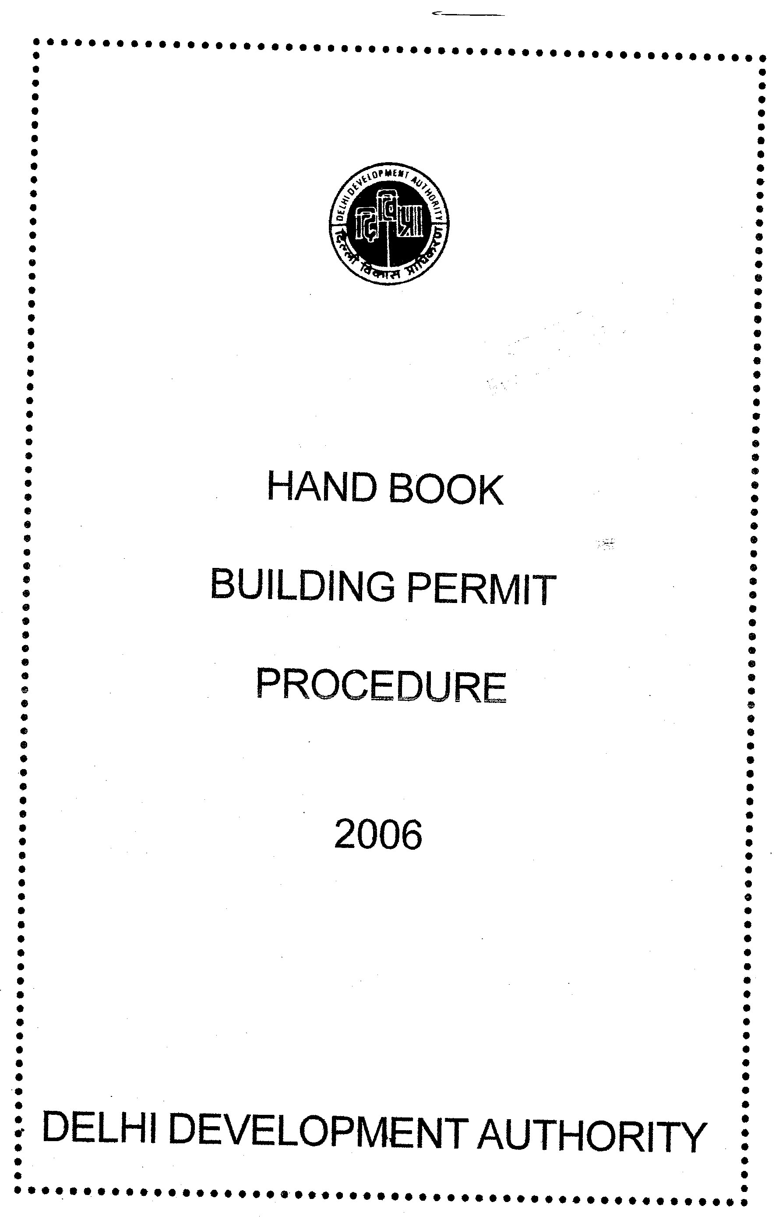
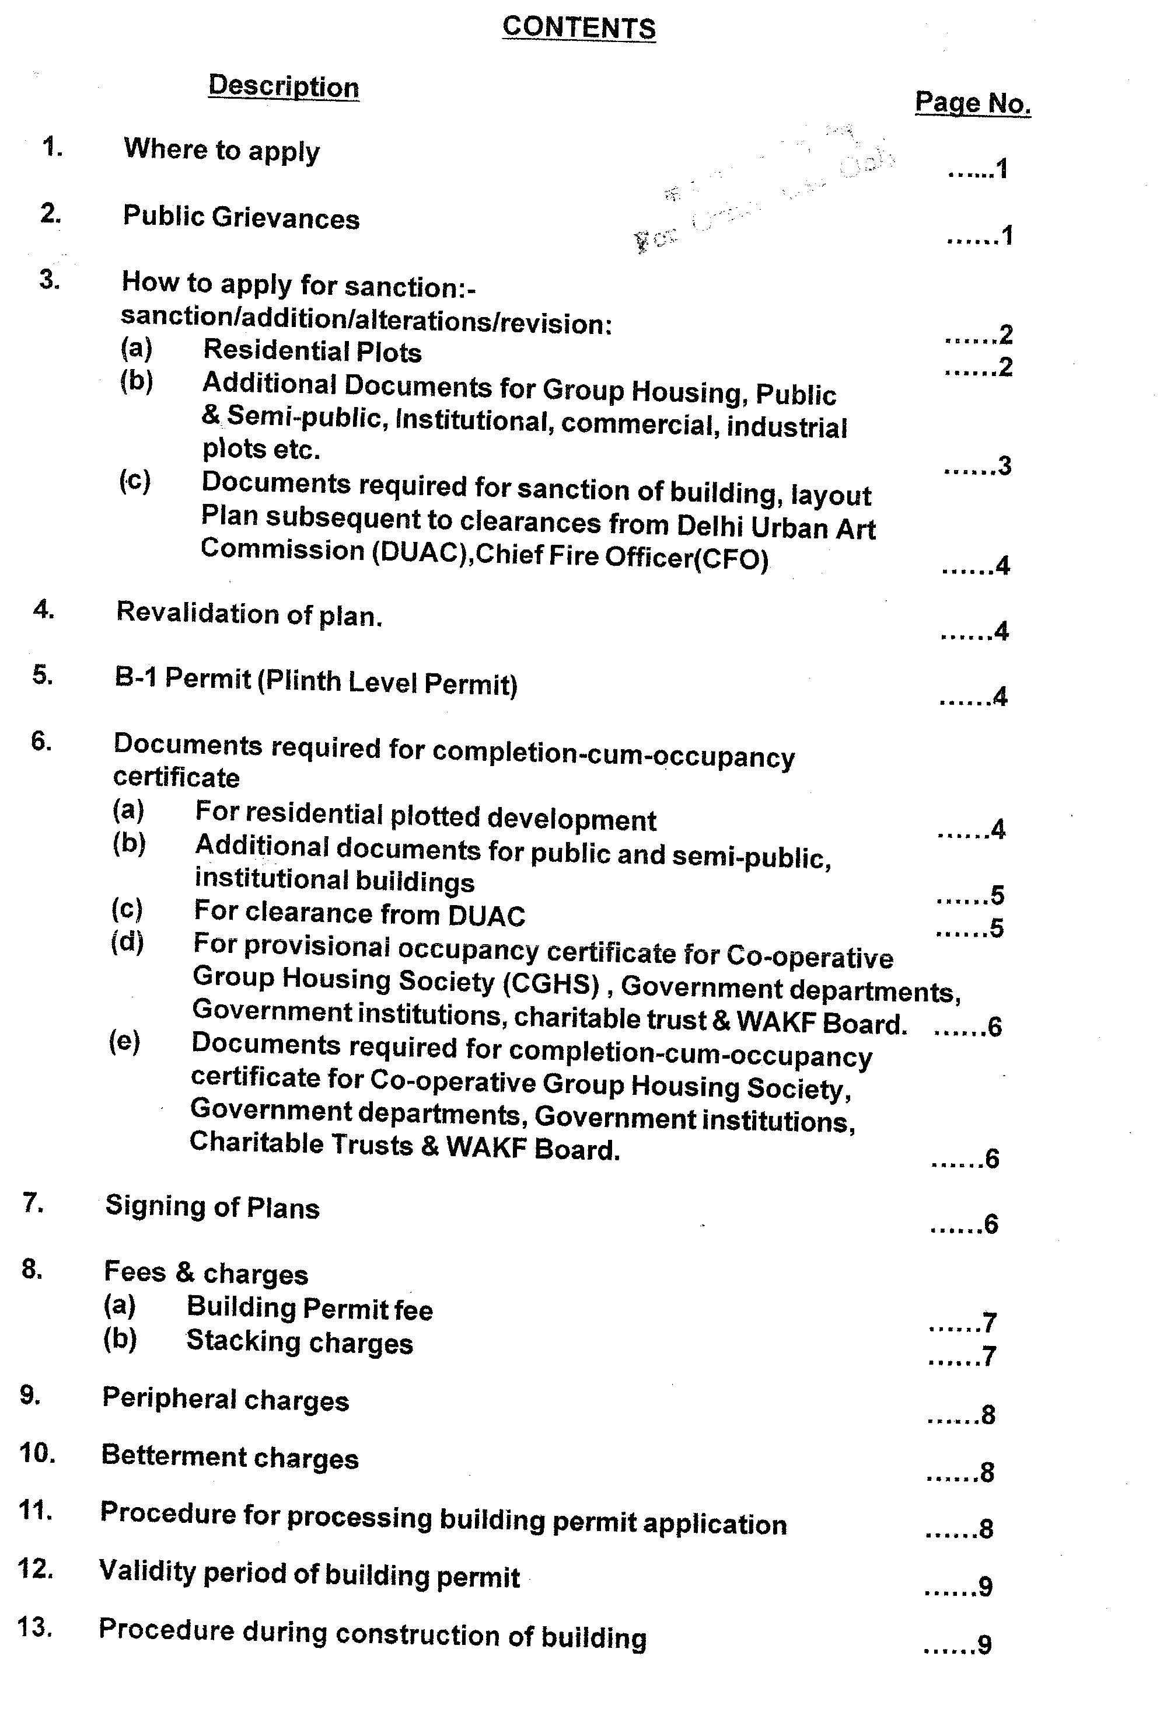
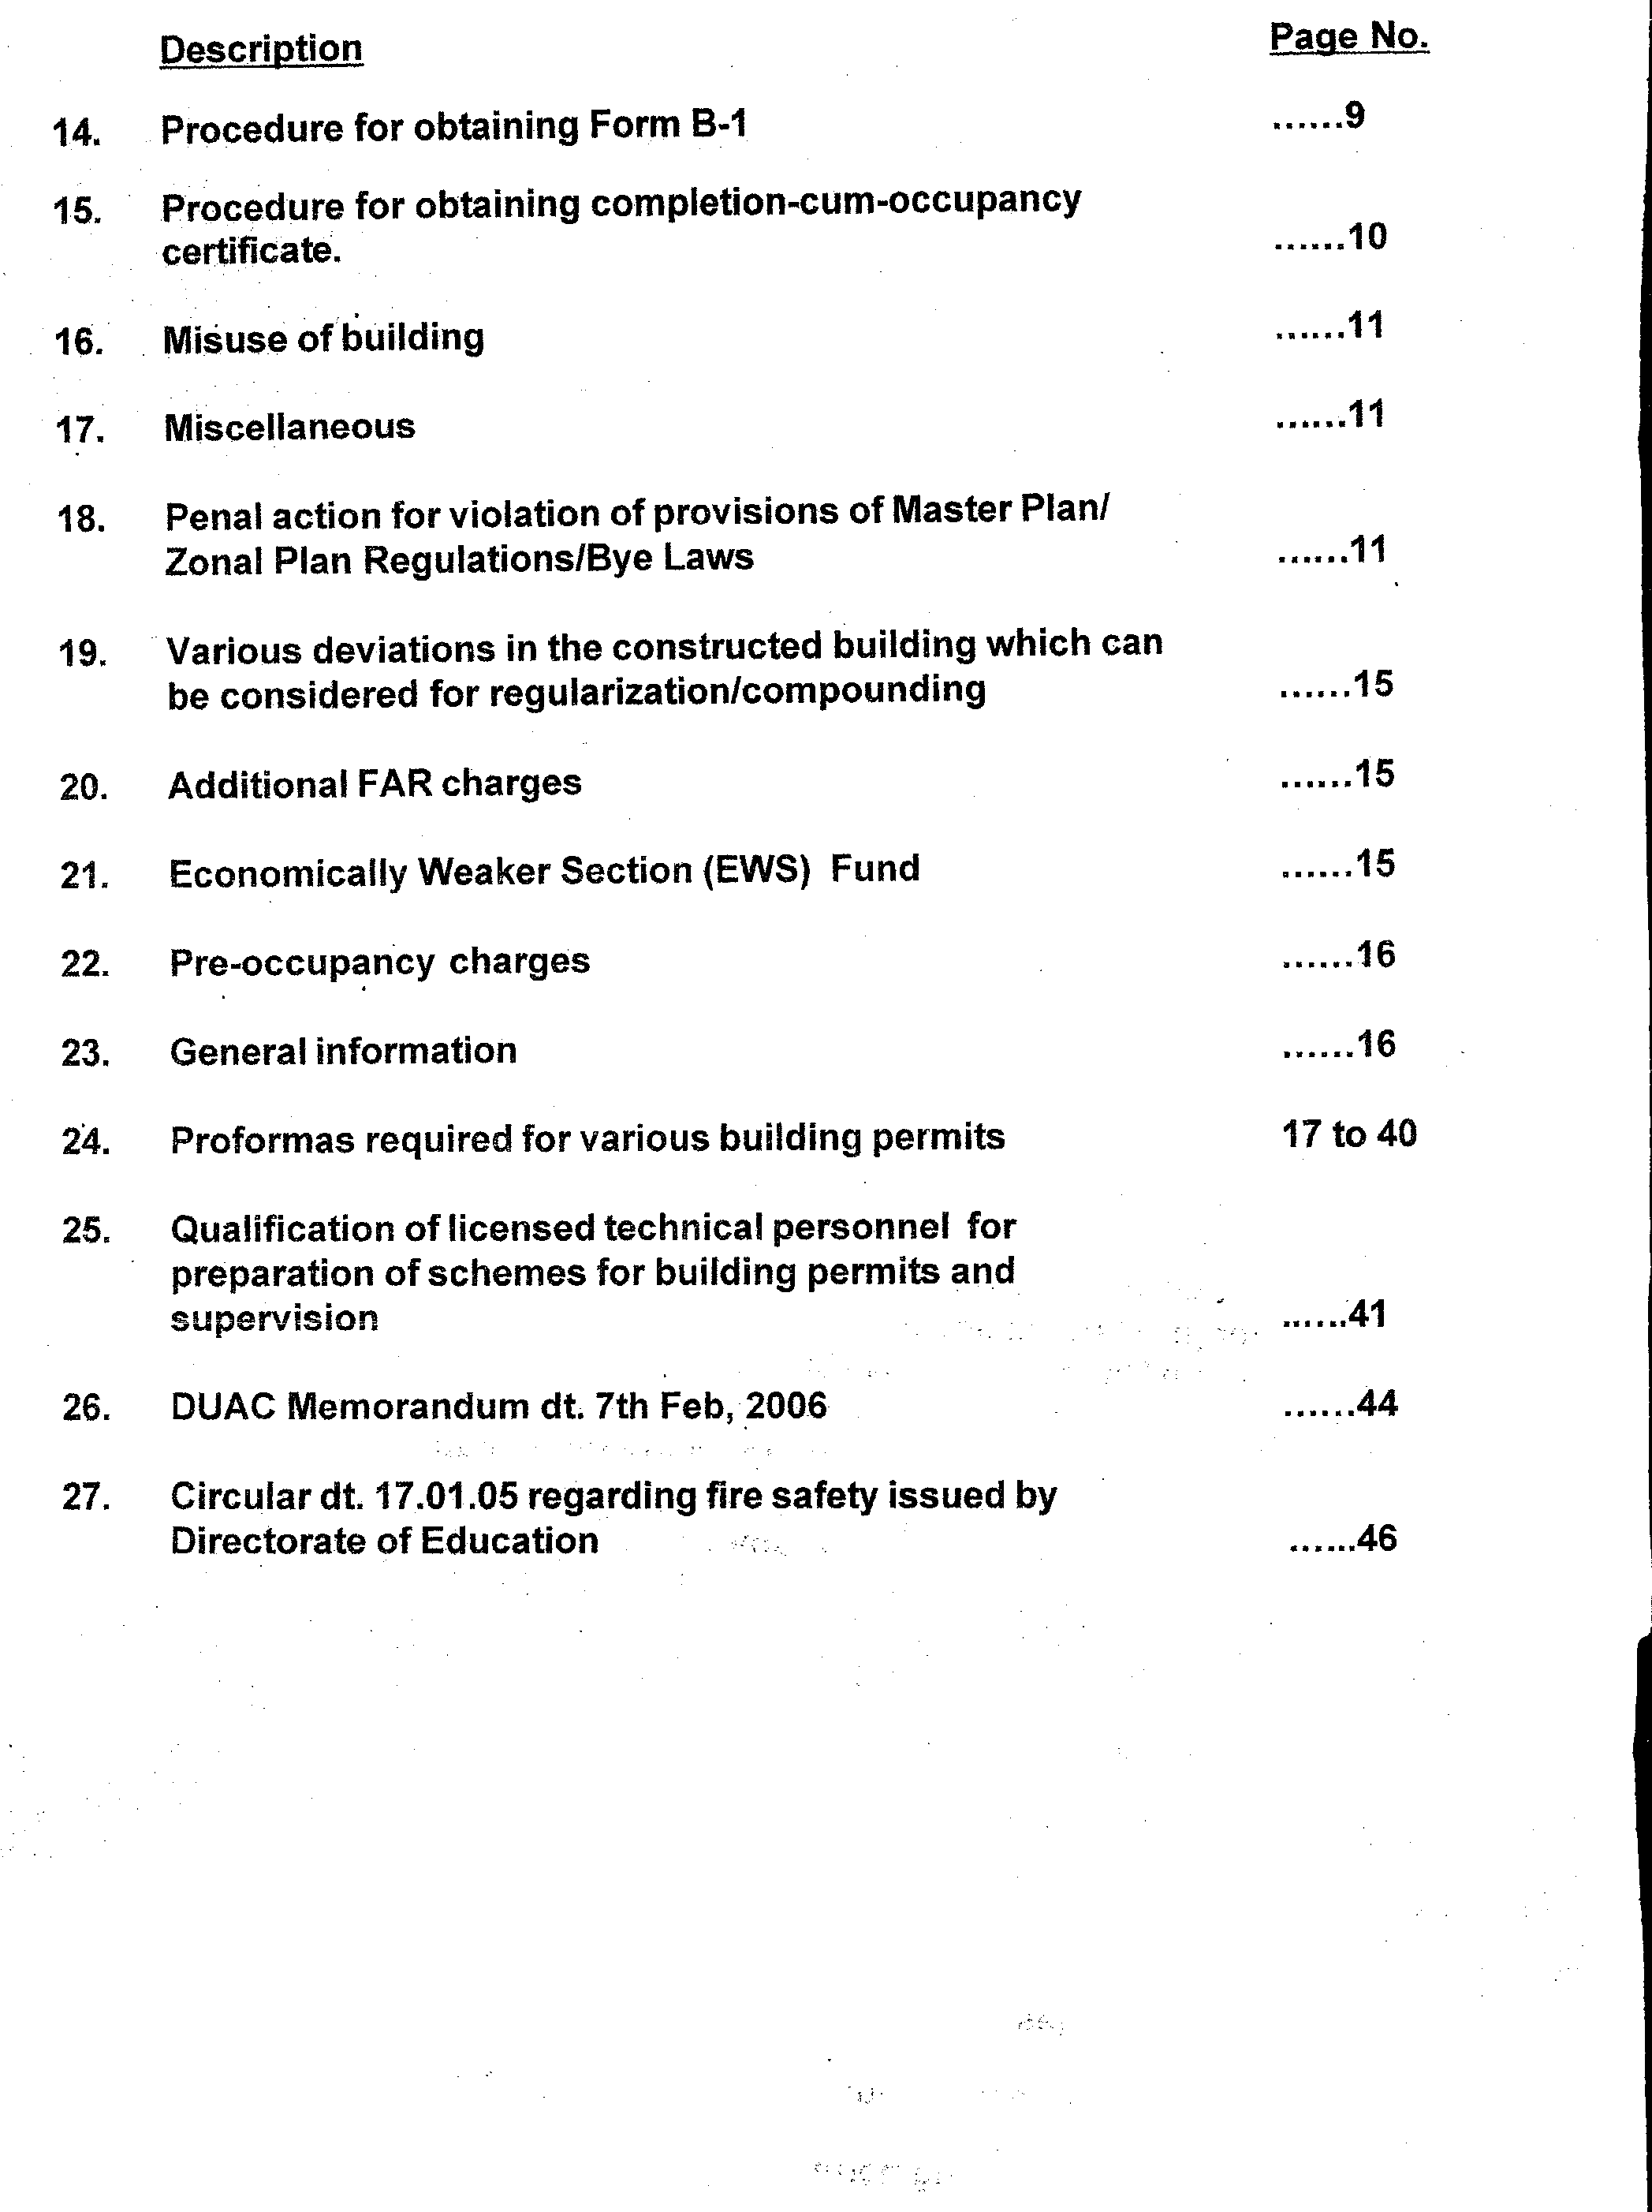

!1'
OELHI DEVELOPMENT AUTHORITY
1. The Building Bye-Laws 1983 as adopted byDelhi Development Authority are applicable for the development areas of the Authority within the National Capital Territory of Delhi as declared under Section-12 of Delhi Development Act, 1957 in exercise of powers conferred under sub-section 1 of Section 57 of Delhi Development Act, 1957. No development shall be allowed in the development area of Delhi Development Authority without proper sanction .
. -?
2. The guidelines and procedure for processing the building plans are as under(inc(uding
notifications of Govt. of India issued from time to time):- .. -
.' ,.-;:./
Where to apply:
v ..
...•. ,..
..
The building plan applications are to be submitted at Building Section Counter, D-Block, Ground Floor, Vikas Sadan, New Delhi-110023 which is situated near I.N.A. Market. Such applications are received on this counter from 10.30 A.M. to 1.00 P.M. and 2.00 P.M. to 4.30 P.M. on all working days. For plotted Residential Development of Rohini other than alternative and auction plots, the building plans are to be submitted at Rohini Project Office, DDA Office Complex, Deepali Chowk, Sector-3, Rohini, Delhi-110085 as per standard plans and regulations. The office of the Building Section is situated at 1st & 2nd floors of Block C-1, Vikas Sadan, New Delhi. Offices of different officers are as given below:
C-1 Block, 2nd floor Vikas Sadan
&
RohiniProject Office 2794231 0 Deepali Chowk, Sect.3,
Rohini-85
S.No .
. Officer
Address
1. 2. 3.
Add!. Commissioner(Plg. )-1" Director(Bldg.)
Dy. Director(lndustrial & Commercial)Bldg.
Jt. Director(Layout & Institutional) Bldg.
Dy. Direc~or(Residential) Bldg.
Jt. Director(Rohini & Narela)Bldg.
C-1 Block, 21}d floor
3rd floor Vikas Minar C-1, Block, 1st floor C~ 1 Block, 2nd floor
4.
C-1 Block, 1st floor
5.
6.
"1'1'·,'
Public Grievances:
Telephone No:
.23379149 24699279 24690431
Extn.2571 24690431 Extn.2529 24690431 Extn2567 24690431 Extn.2514
In case of any grievance, the public can approach the 'ShikayafAdalat'of the Building Deptt. This Adalat is held on every first working Monday of each month between 2.30 PM to 5.30 PM relating to cases with the following
i) Delay in sanction of building plans.
ii) Issuance of B-1 permit.
iii) Issuance' of Completion Certificate.
ivy Problems related to the 'NOC' from lands Section and Planning/Architecture
Department.
( 1 )

Additional Commissioner(Plg.)-1I1 hears the complaints in his office at 3rd f1"''''''
Minar, New Delhi, after giving time and date to the aggrieved party on his/her rep submit!~~ ~~i~ In addition, public hearing is conducted by hi,m on Monday & Thu:sca 9..i{?c(6~(~l9g:?frs also available for redressal of the public complaints/grievances berwee
~'2.'3o,,?Jvtio 5.30 PM in his office on Monday & Thursday.
( " -" >
v~
~o't
. The public hearing days of JUDy. Directors(Bldg.) are Monday and Thursday betv/een

2.30 PM to 5.30 PM wherein problems related to Building Section could be put up by the aggrieved parties for redressal.

How to Apply:

(A) For sanction/Addition/Alterations/Revised plan of residential plot/other buildings.

If a person intends to erect or re-erect or make alterations in a building he/she shall give notice in writing in the prescribed form (Form-I; Appendix .'A'; Bye-Law No. 6.1) and such notice shall be accompanied by necessary permit fee as detailed in Serial NO.3 at
P-8 and the following documents: .

(1) Form for first application-Appendix 'A '(Bye Law NO.6. 1 )(Refer Page-17).
(2) Specification Form of proposal duly signed by owner and Architect/Engineer-Appendix
'A' (Bye Law No. 6.2.6)(Referpage 18).
(3) Certificate of supervision-1-Appendix B' (Bye-Law No.6.2.7) by Architectl
Engineer(Refer Page-19).
(4) Certificate of Supervision-I/ by Plumber/Engineer- Appendix 'B' (Building Bye Law
No. 6. 2. 8)(Refer Page-20).
(5) Appointment letter of Architect/Engineer.
(6) Copy of valid registration certificate of Architect/Engineer.
(~) Copy of valid registration certificate of Plumber/Engineer.
(8) Affidavit on non-judicial stamp paper of Rs. 10/- for ownership and piot iying vacant
(Specimen Annexed)(Refer Page-21).
(9) Affidavit/undertaking on non-judicial stamp paper of Rs. 101- for non-stacking of build-
ing materials on public property(Appendix 'M')(Refer Page-22).
(10) Time Extension, if required, up to the date of submission of building permit.
(11) Indemnity Bond on a nonjudicial paper of Rs. 1001- in case of proposal for construction
of basement(Appendix N') duly attested by First Class Magistra te (Refer Page-23).
(12) Undertaking on nonjudicial paper of Rs. 10/- under Section 29(1jof Delhi Development
Act, 1957 (Specimen Annexed)(Refer Page-24).
(13) Copy of possession plan and Lease Deed.
(14) Copy of NOC issued by Lessor.
(15) Building Plans including water harvesting proposal (4 Sets including one set cloth mounted) duly signed by Owner & Architect.
(16) Landscape Plan(4 sets including one set cloth mounted) duly signed by Owner & Architect.
(17) Parking Plan(4 sets including one set cloth mounted) duly signed by Owner & Architect.
(18) Layout Plan, wherever applicable duly signed by Owner & Architect.
(19) Certificate by owner, Architect/Engineer & suuctural engineer for safety from natural
hazards (Annexure- B'-Bye Law No. 6.2. 9)(Refer Page-25).
(20) Qualification Certificate of Structural Enginee ..

( 2 )

