

Sports is the most potent & powerful mean of social transformation & national reconstruction. Hari Nagar Sports Complex, Delhi Development Authority as part of development and growth of sports in West Delhi was inaugurated by Shri Markandey Singh, Hon’ble Lt. Governor, Delhi on Monday 18 March, 1991, i.e. more than two decades. Hari Nagar Sports Complex is spread out in an area of 6.40 Hect.

The objectives of the DDA Hari Nagar Sports Complex are:-

- To provide recreational & healthy environment to the citizens of Delhi as per the requirement of Master Plan.

- To induce sports activities and spirit of mutual help and goodwill among citizens of Delhi in general and in members of the body in particular.

- To promote various sports i.e. Aerobics, Basket Ball, Swimming, Skating, Squash, Table Tennis, Tennis, Billiards, Badminton, Karate, Yoga, Cricket.

AEROBICS:
Hari Nagar Sports Complex serves as ground for people across a varied demographic practising, enjoying the relaxing, and attempting the rigoures of aerobics. It has provided the A/Cs fitted Aerobics room facility as well as trainers at the Complex. The interested female members come in large number and start availing this facility. Qualified Professional Aerobics Instructors are parting their skills in improving beautification, weight loss and curing diseases of female members through aerobics exercise. The details of classes are as under:

Name of Instructor | Days | Timings | Fee  (Rs.)
Shelly Sisodia | Tuesday to Sunday | 7 am to 8 am | 800 & 1200
R.G.Academy For Fitness | Wednesday, Friday & Sunday | 5pm to 6 pm (Summer)  4.15 to 5.15 pm (Winter) | 500 & 800
Shikha Gurang | Tuesday, Thursday & Saturday | 5pm to 6 pm (Summer)  4.15 to 5.15 pm (Winter) | 500 & 800
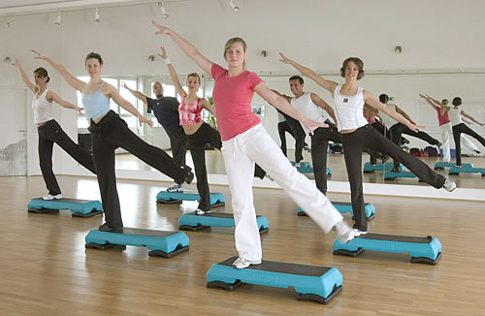

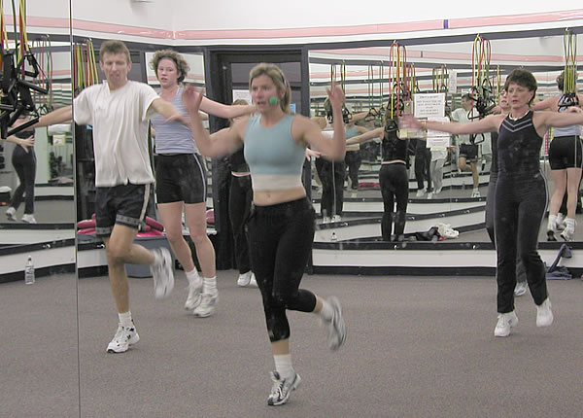
…….2

Badminton:
The Badminton game enjoys mass popularity amongst Indians. It is a game which is very popular amongst not only children but also the adult men & women too.

The services of the following coaches have been extended to the members w.e.f . 01.01.2012. The details of the coaches, their availability on the days & timings are mentioned here under.

Name of the coach | Days | Timing | Fee(Rs.)
Harpreet Singh | Tuesday,  Thursday  & Saturday | 4 pm to 6 pm (summer)  3 pm to 5 pm (winter) | 900& 1200
Parvesh Kumar | Wednesday, Friday  & Sunday | 4 pm to 6 pm (summer)  3 pm to 5 pm (winter) | 900 & 1200

- Harpreet Singh, National Player and qualified coach.
- Parvesh Kumar, National Player and qualified coach.

We are also putting all-out efforts to get the synthetic Badminton flooring as per modern requirement in the indoor hall very soon.

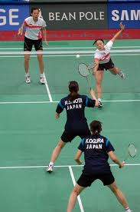
…….3

Billiards/ Snooker:
The sports arrived in India in the 1920s but saw slow progress, perhaps because of its perception as an elitist sport for many years. Yet the game has been played to the highest standards in India as evidenced from the host of world-class performers that the country has produced, making India a force to reckon with in world billiards competitions.

In recent years, however, the game has started catching the fancy of masses. The DDA has set up billiards and snooker facilities in all its sports complexes. It has also ensured that the complexes are staffed with good makers who can advise budding players and help improve their game. The complex also rent out the facilities to schools and colleges for training students or for conducting inter-school/ college championships in the sport. Two tables are being used for both Billiards & Snooker Games. A special provision for a billiard marker is available in the complex. The intending young upcoming talented members wishes to improve their skills can avail the coaching facility for which a regular Billiard marker is available during afternoon hours.

The Complex feel proud to mention that one of our members Shri Rajesh Kumar ( K- 490) has recently won the Delhi Billiards Title.
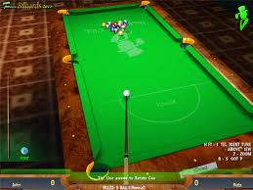
…….4

Basket Ball:
One of the fastest ball games, basketball has the distinction of being one of the most popular and widely played ball games in the DDA Sports complex. The Hari Nagar Sports Complex, apart from providing the basketball court, has also made special coaching arrangements to further promote the sport at a professional level. Summer and winter coaching camps are held within the complex to identify and nurture fresh talent.

Sh. Veenu Gopal, the former National player and Ms Divya Singh, an international are making all efforts to entertain the talented, young, up-coming boys & girls throughout 3 days a week in the evening hours through his entertaining skills. The details of the coaching are as under:-

Name of the Coach | Days | Timing | Fees(Rs.)
Veenu Gopal | Tuesday  to  Saturday | 5 pm to 7 pm (Summer)  4.30 pm to 6.30 pm (Winter) | 500 & 800
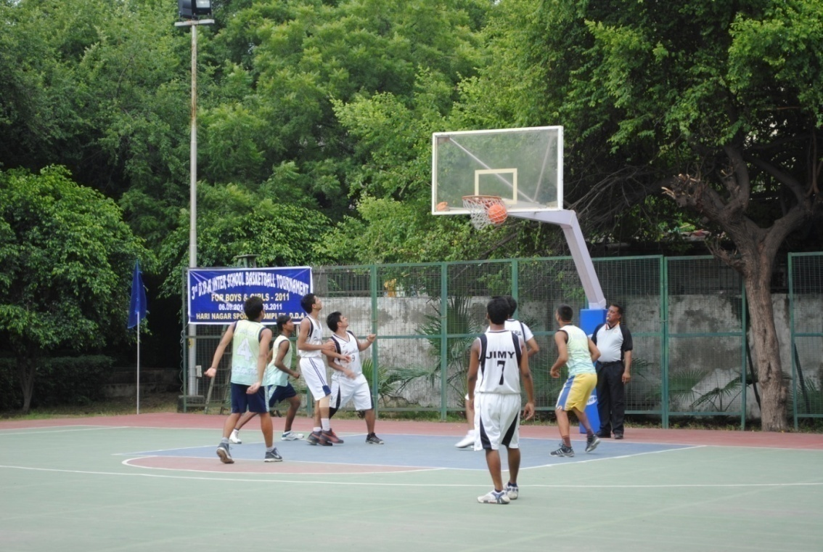
…….5

Ms. Divya Singh, the former International player is making all efforts to entertain the talented, young, up-coming boys & girls throughout 3 days a week in the evening hours through her entertaining skills.

The details of the coaching are as under:

Name of the Coach | Days | Timing | Fees(Rs.)
Ms Divya Singh | Wednesday,  Friday  & Sunday | 5 pm to 7 pm (Summer)  4.30 pm to 6.30 pm (Winter) | 400& 600

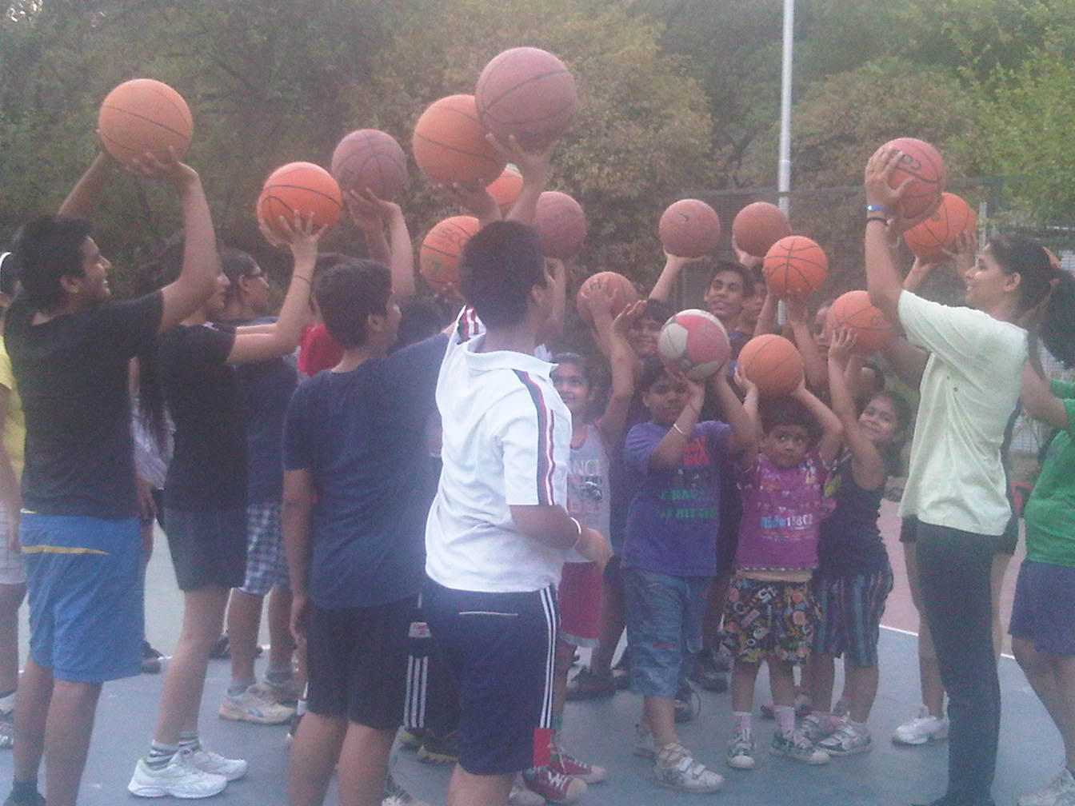
- Ms Divya Singh, Coach parting with her skill with dependent children at Basket-ball Court.

- Ms Divya Singh, is presently the Coach of Delhi State Basket-ball Girls’ Team.
…….6

CRICKET:
Cricket is a very popular game in India. It is popular in the complex also. We had a record number of users. Sometimes especially during summer vacations, the management had to cut sorry figure to the new entrants. This crowd has compelled the management to develop another cricket ground, bigger in size, in the vicinity of the complex. More so, the management has added another cricket academy under the supervision of former Indian Test player “Sanjeev Sharma”. The existing one is being managed efficiently by former Delhi Ranji Player “R.K Sharma”. The details of the coaching are as under:

Name of the coach | Days | Timing | Fee(Rs.)
R.K. Sharma | Wednesday,  Friday &  Saturday | 4 pm to 6.30 pm (Summer)  3.30 pm to 6 pm (Winter) | 550 & 1000
Sanjeev Sharma | Tuesday,  Thursday &  Sunday | 4 pm to 6.30 pm (Summer)  3.30 pm to 6 pm (Winter) | 550 & 1000

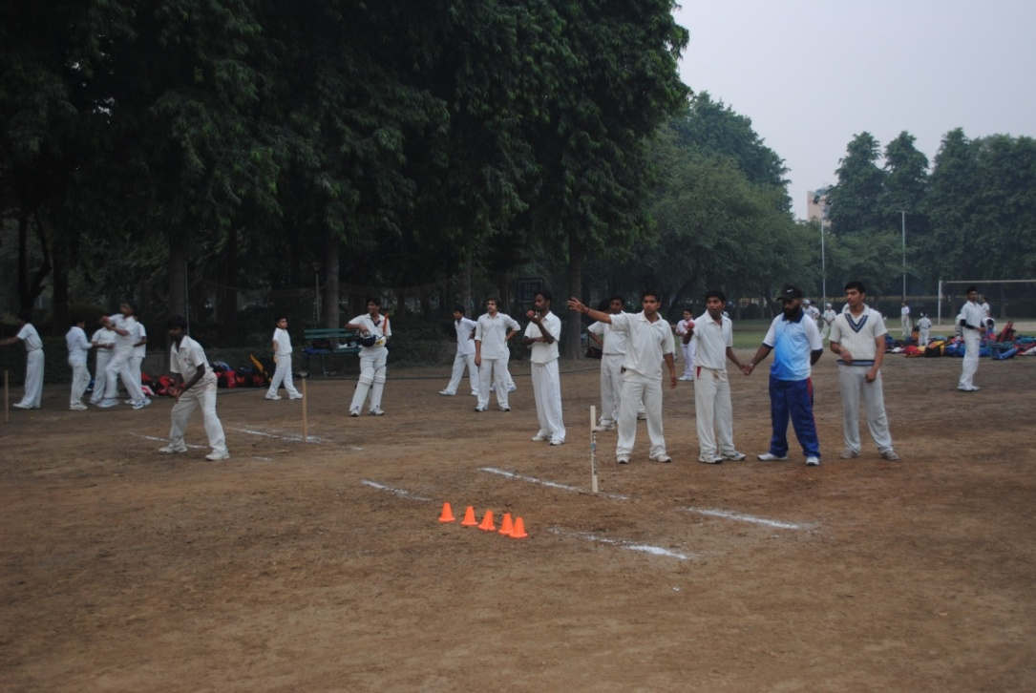

…….7
KARATE/KICK BOXING:
Your hands and feet are your weapons if you know how to use them properly. Karate and Kickboxing – martial arts systems of codified practices and traditions of unarmed combat teach you just that. The modern forms of these arts are a combination of traditional synchronized hand and leg movements along with the training of mind, which encourages the inculcation of self-confidence, self-realisation and discipline. The detail of the coaching is as under:-

Name of the coach | Days | Timing | Fee(Rs.)
Dinesh Rawal | Tuesday, Thursday & Saturday | 6 pm to 7 pm (Summer)  5 pm to 7 pm (Winter) | 300/- & 600/-

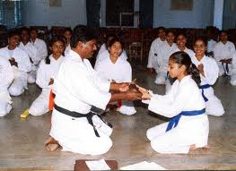

…….8

SWIMMING:
Perhaps the most-loved exercise across the globe, the cool, crystalline waters of a pool can only beckon. Recreational or professional, swimming is seen as an ideal way to exercise all the muscles of the body in manner that calms the mind and soothes the soul. We have a club size Swimming Pool which is a great attraction to the members and their guests during the summer season. The quality of the water in the swimming pool is one of the best in the area. We organize special Swimming Coaching camps in the month of May–June every year for the children between the age of 8 to 16 years. The duration of the each camp remains 15 days.

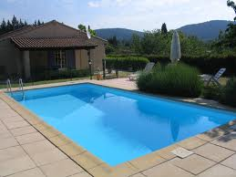

A glamorous view of swimming pool

…….9
CHARGES/ FEES PER DIP FOR ONE HOUR WILL BE AS UNDER for members: -

1. SEASONAL PASS : Rs. 1800/-

2. Quarterly Pass : Rs. 1500/-
(from April to June)

3. Quarterly Pass : Rs. 800/-
(from July to Sept)

4. MONTHLY PASS : Rs. 500/-

5. DDA STAFF (SEASONAL PASS) : Rs. 500/-

DDA STAFF (MONTHLY PASS) : Rs. 100/-

6. DAILY FEE :
(Per dip for one hour)

(a) MEMBERS : Rs. 30/-
(with valid Membership card)

(b) GUEST : Rs. 120/-
(Accompanied by Member)

7. COACHING FEE : Rs. 500/-

…….10
Skating:

Roller skating is the traveling on smooth surfaces with roller skates. It is a form of recreation as well as a sport, and can also be a form of transportation. Skates generally come in three basic varieties: quad roller skates, inline skates or blades and tri-skates, though some have experimented with a single-wheeled "quintessence skate" or other variations on the basic skate design. In America, this hobby was most popular in the 1970s and the 1990s.

The detail of the coaching are as under: -

Name of the coach | Days | Timing | Fee (Rs.)
Pushpender Kr. Moga | Tuesday,  Thursday,  Saturday &  Sunday | 6 pm to 8 pm (summer)  5 pm to 7 pm  (winter) | 300 & 600

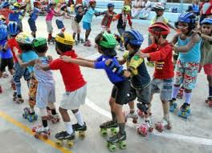

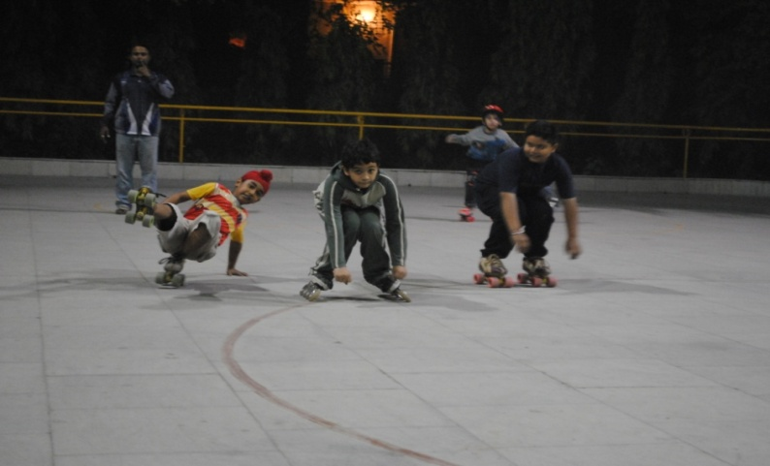 …….11

Squash:
Squash provides an excellent cardiovascular workout. In one hour of squash, a player may expend approximately 600 to 1000 calories (3,000 to 4,000 kJ),.^{[7]} The sport also provides a good upper and lower body workout by utilizing both the legs to run around the court and the arms and torso to swing the racquet. We have recently relaid the flooring with maple wood as per latest- requirement. Hence we advise all the users to wear only non-marking shoes while entering the playing arena.

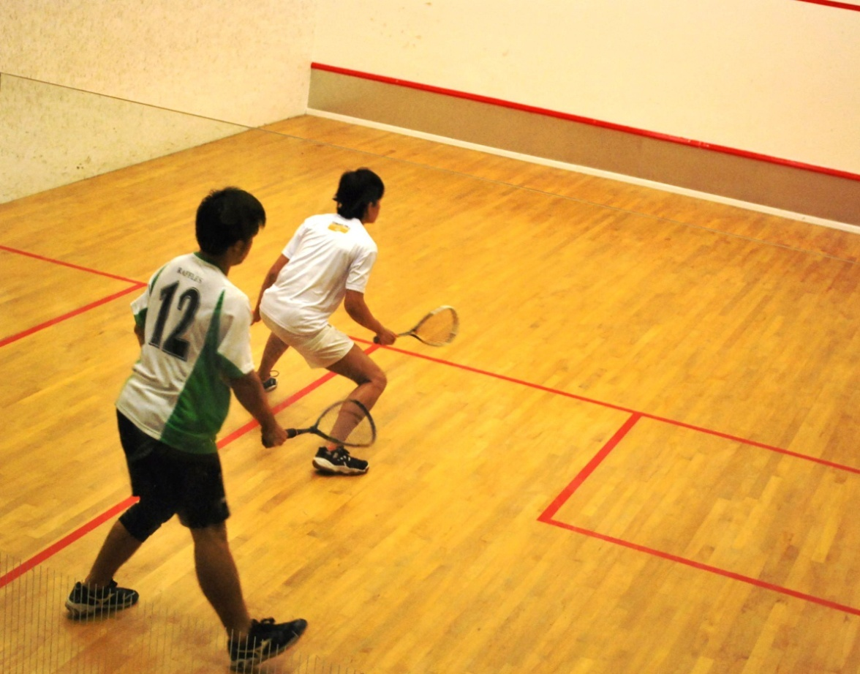

A view of squash court with wooden flooring

…….12

Table Tennis:
The dexterity and quick response requirements of the game make this mesmerizingly fast-paced game extremely energy –driven and needing a lot of stamina and focus. The complex is equipped with table tennis tables and coaches to guide players to play with precision. It is endearing to see school and college-going student fine-tuning their skills at the game in this complex. On the demand of the members, Table Tennis coaching is also being parted with. The details of the coaching are as under:

Name of the Coach | Days | Timing | Fees(Rs.)
Netaji Subhash Sports & Welfare Association  Coach- Nirmal Chandra Duklan | Wednesday, Saturday &  Sunday | 4.00 pm to 6.00 pm (summer)  3.00 pm to 5.00 pm (winter) | 400 & 800
Wills Sports Academy  Coach- Ankita Aggarwal | Tuesday ,  Thursday &  Friday | 4.00 pm to 6.00 pm (Summer)  3.00 pm to 5.00 pm (Winter) | 400 & 800
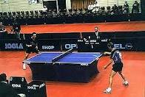

…….13

Tennis:

On the demand of the members, coaching is also being extended at newly developed synthetic courts under the following coaches:

Name of the Coach | Days | Timing | Fees(RS.)
Tennis (Hard Courts)  Saifco Tennis Academy | Wednesday,  Friday &  Sunday | 4.00 pm to 7.00 pm  (Summer)  3.00 pm to 6.00 pm  (winter) | 500 & 900
Tennis (Hard Courts)  Saba Tennis Academy  Coach - Mohd. Tahir | Tuesday,  Thursday &  Saturday | 4.00 pm to 6.00 pm  (Summer)  3.00 pm to 5.00 pm  (winter) | 500/- &  900/-
Tennis (Synthetic Courts)  Coach - Jay Prakash | Wednesday,  Friday &  Sunday | 4.00 pm to 7.00 pm  (Summer)  3.00 pm to 6.00 pm  (winter) | 1000/- &  1500/-
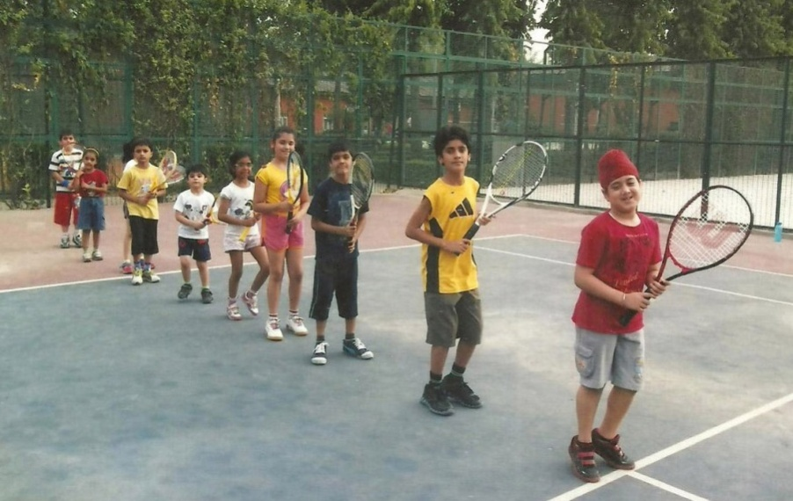

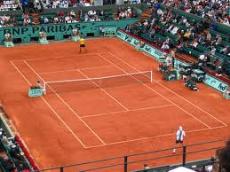

……..14
Yoga:

Perhaps one of the quietest disciplines of exercising, yoga is an amalgam of traditional physical and mental disciplines that originated in India. A veritable healing system of theory and practice, yoga features a combination of breathing exercises, physical postures, and mediation that has been practised for more than 5,000 years.

For those not inclined towards harder sports, yet keen to maintain good health and form, yoga is the most viable option. By its very nature and form, yoga is believed to not only heal the body but also to calm the soul. Its combination of meditative and physical poses helps one attain an inner peace that goes a long way in maintaining good health.



…….15

How to become member:-

INDIVIDUAL MEMBERSHIP

- Forms of Individual Membership are 6th of every Month to
Available during -- 24th of every Month

- Membership forms can be submitted -- 1030 hours to 1630 hours
in the office on all working days

- Membership granted with effect from -- 1st of followed Month
- Documents required along with membership forms are
- Application – Addressed to Secretary, Hari Nagar Sports Complex, DDA.
- Bio-Data (Name, Address, Date of Birth, Occupation, Qualification, Telephone number & E- Mail Id)
- Residence Proof (copy of Passport; Election Id; Driving license etc)

- Amount to be Deposited as Entry fee (Non-Refundable):

Entry Fee(Rs) | Service Tax (Rs) | Total (Rs) | Category
10,000.00 | 1236.00 | 11236.00 | Business/Private Sector
5,000.00 | 618.00 | 5618.00 | Govt. Servant(Central/Delhi Govt. Employees only)
1,000.00 | 124.00 | 1124.00 | Staff of DDA
2,000.00 | 247.00 | 2247.00 | Senior Citizen i.e. above 60 yrs.

.........16

- General category :- Rs. 11236/- &
One year advance monthly subscription;

- Govt. Category :- Rs. 5618/- &
One year advance monthly subscription;
- Current pay slip (attested)
- Photo copy of I-card (attested)

- Sr. Citizen : Rs. 2247/- &
One year advance monthly subscription
- Age proof (attested)

- Three photographs for main member & two photographs for each dependent.
- Dependent : - Spouse & Children (5 to 21 years)

The membership is also available on temporary basis for three months with the following charges:-

Temporary Membership
(Only for 3 months)

- Membership forms can be obtained
From office. -- 25th of every month
- Membership forms can be submitted
In the office -- upto 5th of the followed month
- Membership granted
With effect from -- 1st of every month
…….17

- Documents required alongwith membership forms are
- Two photographs each duly pasted.
- Photocopy of residence proof.
- Application form should be proposed by any regular member of HNSC.

- Charges for temporary membership.
Applied for | Entrance fee | Dependent charges | Service tax | Total amount
Self | 1000.00 | - | 124.00 | 1124.00
With 1 dependent | 1000.00 | 150.00 | 142.00 | 1292.00
With 2 dependent | 1000.00 | 300.00 | 161.00 | 1461.00
With 3 dependent | 1000.00 | 450.00 | 179.00 | 1629.00
With 4 dependent | 1000.00 | 600.00 | 198.00 | 1798.00

Demand draft/banker cheque is to be made in favour of “Hari Nagar Sports Complex, DDA” .

One who is not a member and w0uld like to use the facilities can do so on becoming member for a day on payment of casual fee of Rs.40/-.

Guest accompaning the member can avail the facility on payment of rs.25/- each.

Students can avail the facility on production of identity card of school in between 1000 hours and 1500 hours on payment of Rs.10/- each.

……..18

It is also informed that the complete details of each & every member are being uploaded. Very soon, all the information of the complex would be available on the Website. You may visit website- dda.org.in, E-mail Id:- ddahnsc@rediffmail.com or ddahnsc@gmail.com you may also kindly let us know your Mobile Number/E-mail which will facilitate both of us for regular interaction & day to day activities of the complex etc.

While it is our constant endeavor to provide you with the best services, if you face any issue, please write back to us. We would nevertheless encourage you to visit www. dda.org.in/sports. The rates & fee structure is subject to change from time to time.

For further information may contact
Main reception - Phone number 25136683 ;
Secretary - phone number 25147358 ;
Manager - Phone number 25136683 ;
Assistant Accounts Officer - Phone number 25136683 ;

We wish every member pleasant morning/evening whenever they spare time and utilise the facilities available in the complex.

